**Supplementary Material (Figures S1-3 and Tables S1-3)**

**Figures**

**Figure S1.** Water-vapor flux vectors (kg·m−1·s−1) for summer from June to August that were vertically combined from surface to 300 hPa in 1971–2000 based on the NCEP/NCAR reanalyzed data (Kalnay et al., 1996). Locations of fossil pollen records synthesized from northern China (see Table S1 for details). EASM, ISM, and Westerlies represent the East Asian monsoon, Indian monsoon, and westerlies, respectively. Green dashed line denotes the northern boundary of modern summer monsoon modified from Chen et al. (2010).

**Figure S2.** Statistical performance of pollen-based calibration models for PANN and TANN. Performance statistics include coefficient of determination (R2), root-mean-square error of prediction (RMSEP), and maximum (Max.) bias. Scatter plots show predicted versus observed values for PANN (mm) or TANN (°C), and residuals of predicted versus observed values for PANN or TANN.

**Figure S3.** The original pollen-based stacked PANN (±232.06 mm) or TANN (±3.62 °C) reconstructions based on 22 individual reconstructions from fossil pollen records of 11 lake sediments cores in monsoonal northern China.

**Tables**

**Table S1.** Summary of fossil pollen records for PANN and TANN reconstructions from 11 lakes in monsoonal northern China.

**Table S2.** AMS radiocarbon dates and calibrated ages of 11 fossil records (see Table S1 for references).

**Table S3.** Information regarding 17 Chinese historical records from the Han to Qing Dynasty including economic level, grain yield grade, grain price index, fiscal grade, agriculturalist policy territory, extreme flood years, extreme drought years, freeze disaster frequency, sand-dust event frequency, famine index, locust frequency, epidemic disaster frequency, peasant uprising frequency, number of wars, number of southward nomadic migrations, farming-pastoral boundary, and number of estimated human population.

**Figure S1**

**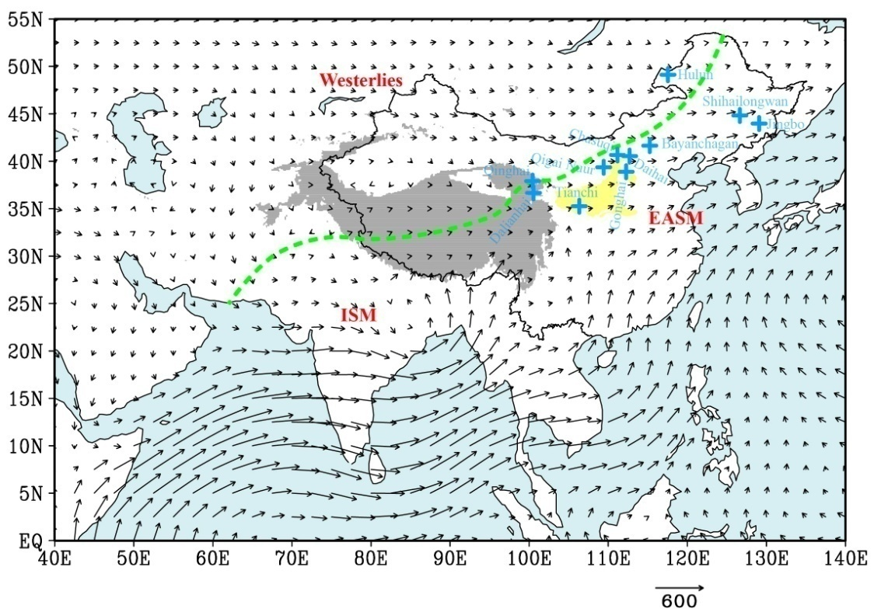**

**Figure S2**

C:\Users\lijianyong\Desktop\Fig_S2.tif

**Figure S3**

**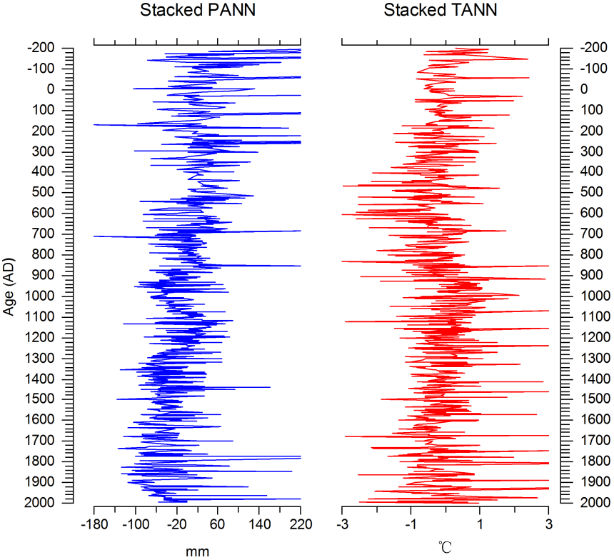**

**Table S1** Summary of fossil pollen records for PANN and TANN reconstructions from 11 lakes in monsoonal northern China.

|  |  |  |  |  |  |  |  |  |
| --- | --- | --- | --- | --- | --- | --- | --- | --- |
| Lake | Lati. | Long. | Alt. | Num. | Res. | PANN | TANN | Reference |
|  | (°) | (°) | (m) | dates | (yrs) | (E/T) | (E/T) |  |
| Bayanchagan | 41.65 | 115.21 | 1355 | 7 | 130 | E | E | Jiang et al., 2006 |
| Daihai | 40.58 | 112.67 | 1225 | 8 | 30 | E | E | Xiao et al., 2004;  Xu et al., 2010 |
| Dalianhai | 37.91 | 100.41 | 2850 | 10 | 80 | T | T | Cheng et al., 2013 |
| Gonghai | 38.90 | 112.23 | 1860 | 34 | 20 | E | E | Chen et al., 2015;  Zhang, 2015 |
| Hulun | 49.13 | 117.51 | 545 | 13 | 65 | E | E | Wen et al., 2010 |
| Jingbo | 43.98 | 129.03 | 350 | 9 | 18 | T | T | Chen et al., 2014 |
| Chasuqi | 40.67 | 111.13 | 1000 | 4 | 90 | T | T | Wang et al., 1997 |
| Qigai Nuur | 39.37 | 109.39 | 1300 | 17 | 50 | E | E | Sun and Feng, 2013 |
| Qinghai | 36.67 | 100.52 | 3200 | 6 | 70 | T | T | Liu et al., 2002;  Shen et al., 2005 |
| Sihailongwan | 44.83 | 126.60 | 833 | 40 | 55 | E | T | Stebich et al., 2015 |
| Tianchi | 35.26 | 106.31 | 2430 | 19 | 85 | E | E | Zhao et al., 2010;  Li et al., 2014 |

Lati. = latitude; Long. = Longitude; Alt. = Altitude; Num. = Number; Res. (yrs) = Resolution (years/sample); E = Earlier publications; T = This study

**Table S2** AMS radiocarbon dates and calibrated ages of 11 fossil records (see Table S1 for references).

|  |  |  |  |  |
| --- | --- | --- | --- | --- |
| Site | Depth (cm) | Dating material | 14C age (yr BP) | Calibrated ages (2σ-range) (Cal. yr BP) |
| Bayanchagan | 0–2 | TOC | 570±50 | 520–648 |
|  | 34–36 | TOC | 3570±60 | 3693–3989 |
|  | 40–42 | TOC | 3830±70 | 4418–4074 |
|  | 46–48 | TOC | 5270±50 | 6122–5925 |
|  | 76–78 | TOC | 7040±80 | 7685–7973 |
|  | 148–150 | TOC | 9760±130 | 10,693–11,439 |
|  | 178–180 | TOC | 10,500±140 | 11,934–12,908 |
|  |  |  |  |  |
| Daihai | 160 | Organic matter | 1434±28 | 1385–1290 |
|  | 402 | Organic matter | 2688±27 | 2845–2750 |
|  | 501 | Organic matter | 3531±28 | 3885–3700 |
|  | 701 | Organic matter | 4729±32 | 5585–5325 |
|  | 901 | Organic matter | 5809±33 | 6720–6500 |
|  | 989 | Organic matter | 6593±34 | 7565–7430 |
|  | 1063 | Organic matter | 9175±34 | 10,470–10,235 |
|  | 1103 | Organic matter | 10,171±39 | 12,300–11,570 |
|  |  |  |  |  |
| Dalianhai | 3.53 | Plant remains | 1140±80 | 687 |
|  | 4.98 | Plant remains | 1955±80 | 1470 |
|  | 12.35 | Plant remains | 3587±30 | 3422 |
|  | 25.85 | Plant remains | 8817±65 | 9483 |
|  | 29.76 | Plant remains | 9860±70 | 10,720 |
|  | 30.00 | Plant remains | 10,268±53 | 11,257 |
|  | 35.43 | Plant remains | 10,620±40 | 12,022 |
|  | 39.00 | Plant remains | 11,668±83 | 13,180 |
|  | 40.00 | Plant remains | 12,464±140 | 13,937 |
|  | 40.04 | Plant remains | 12,690±72 | 14,165 |
|  |  |  |  |  |
| Gonghai | 0.46 | Plant macrofossils | 150±30 | 0–282 |
|  | 0.63 | Plant macrofossils | 368±23 | 332–498 |
|  | 1.07 | Plant macrofossils | 570±25 | 540–628 |
|  | 1.16 | Plant macrofossils | 665±34 | 565–668 |
|  | 1.99 | Plant macrofossils | 1005±40 | 804–963 |
|  | 2.49 | Plant macrofossils | 1102±30 | 968–1053 |
|  | 3.63 | Plant macrofossils | 1329±25 | 1194–1294 |
|  | 4.06 | Plant macrofossils | 2231±35 | 2159–2325 |
|  | 5.21 | Plant macrofossils | 2821±29 | 2878–2956 |
|  | 5.38 | Plant macrofossils | 3440±30 | 3640–3813 |
|  | 5.48 | Plant macrofossils | 4089±39 | 4455–4797 |
|  | 5.72 | Plant macrofossils | 4760±40 | 5470–5583 |
|  | 6.00 | Plant macrofossils | 5944±36 | 6727–6844 |
|  | 6.31 | Plant macrofossils | 6550±40 | 7427–7485 |
|  | 6.44 | Plant macrofossils | 6890±50 | 7674–7785 |
|  | 6.49 | Plant macrofossils | 7001±54 | 7765–7930 |
|  | 6.58 | Plant macrofossils | 7120±40 | 7876–7995 |
|  | 7.03 | Plant macrofossils | 8670±40 | 9550–9659 |
|  | 7.35 | Plant macrofossils | 9464±42 | 10,602–10,758 |
|  | 7.61 | Plant macrofossils | 10,020±50 | 11,360–11,690 |
|  | 7.66 | Plant macrofossils | 10,252±39 | 11,839–12,084 |
|  | 8.02 | Plant macrofossils | 10,667±83 | 12,655–12,820 |
|  | 8.54 | Plant macrofossils | 11,930±50 | 13,725–13,859 |
|  | 8.91 | Plant macrofossils | 11,490±140 | 13,203–13,477 |
|  | 9.42 | Plant macrofossils | 12,518±49 | 14,487–14,883 |
|  |  |  |  |  |
| Hulun | 0–1 | Organic matter | 685±21 | 0– -10 |
|  | 19–20 | Organic matter | 1335±22 | 550–610 |
|  | 34–35 | Organic matter | 1611±22 | 770–930 |
|  | 49–50 | Organic matter | 2543±22 | 1710–1870 |
|  | 59–60 | Organic matter | 3222±29 | 2480–2650 |
|  | 69–70 | Organic matter | 3630±27 | 2970–3220 |
|  | 79–80 | Organic matter | 4034±30 | 3470–3690 |
|  | 89–90 | Organic matter | 4575±31 | 4230–4430 |
|  | 101–102 | Organic matter | 5304±27 | 5290–5470 |
|  | 109–110 | Organic matter | 6338±35 | 6310–6510 |
|  | 119–120 | Organic matter | 7285±30 | 7430–7570 |
|  | 129–130 | Organic matter | 8003±38 | 8010–8200 |
|  | 149–150 | Organic matter | 9268±38 | 9480–9660 |
|  |  |  |  |  |
| Jingbo | 28.5 | Leaf fragment | Modern carbon | Modern carbon |
|  | 100 | Leaf fragment | 110±30 | 10–270 |
|  | 282 | Leaf fragment | 1150±30 | 980–1170 |
|  | 519 | Leaf fragment | 2210±30 | 2140–2330 |
|  | 700 | Leaf fragment | 2790±30 | 2800–2960 |
|  | 750 | Leaf fragment | 2830±30 | 2860–3040 |
|  | 815 | Leaf fragment | 3160±30 | 3350–3440 |
|  | 965 | Leaf fragment | 3850±30 | 4150–4410 |
|  | 1154 | Leaf fragment | 4420±30 | 6350–6540 |
|  |  |  |  |  |
| Chasuqi | 33–37 | Peat | 1650±80 | 1356–1720 |
|  | 55–60 | Peat | 2160±75 | 1989–2339 |
|  | 211–216 | Peat | 8200±80 | 9001–9406 |
|  | 258–263 | Peat | 9050±150 | 9701–10,541 |
|  |  |  |  |  |
| Qigai Nuur | 0–2 | Bulk sediment | 1950±50 | 0 |
|  | 84–85 | Bulk sediment | 2700±70 | 557–893 |
|  | 94–95 | Bulk sediment | 2780±60 | 671–906 |
|  | 124–125 | Bulk sediment | 2480±60 | 508–636 |
|  | 154–155 | Bulk sediment | 2490±40 | 505–652 |
|  | 174–175 | Bulk sediment | 3120±60 | 962–1257 |
|  | 209–210 | Bulk sediment | 3280±40 | 1178–1309 |
|  | 231–232 | Bulk sediment | 3490±60 | 1318–1536 |
|  | 261–262 | Bulk sediment | 3540±60 | 1349–1680 |
|  | 301–302 | Bulk sediment | 3760±40 | 1624–1865 |
|  | 381–382 | Bulk sediment | 6120±70 | 4455–4853 |
|  | 450–451 | Bulk sediment | 7340±60 | 6000–6293 |
|  | 501–502 | Bulk sediment | 8340±110 | 7019–7553 |
|  | 541–542 | Bulk sediment | 9320±60 | 8036–8327 |
|  | 571–572 | Bulk sediment | 9670±90 | 8349–8749 |
|  | 601–602 | Bulk sediment | 9650±50 | 8406–8586 |
|  | 631–632 | Bulk sediment | 10,170±60 | 9024–9401 |
|  |  |  |  |  |
| Qinghai | 120 | TOC | 2400±100 | 1567 |
|  | 230 | TOC | 5060±90 | 4505 |
|  | 355 | TOC | 6760±180 | 6528 |
|  | 475 | TOC | 9660±140 | 9661 |
|  | 675 | TOC | 14,820±180 | 16,540 |
|  | 745 | TOC | 15,610±90 | 17,454 |
|  |  |  |  |  |
| Sihailongwan | 45.0 | Plant remains | 525±25 | 511–624 |
|  | 47.0 | Plant remains | 335±32 | 309–478 |
|  | 77.5 | Plant remains | 1313±40 | 1173–1302 |
|  | 97.0 | Plant remains | 1784±41 | 1573–1821 |
|  | 98.0 | Plant remains | 1725±35 | 1548–1711 |
|  | 118.8 | Plant remains | 2128±42 | 1992–2304 |
|  | 128.0 | Plant remains | 2450±30 | 2359–2702 |
|  | 147.0 | Plant remains | 2917±43 | 2929–3214 |
|  | 163.0 | Plant remains | 3362±51 | 3464–3719 |
|  | 165.3 | Plant remains | 3460±50 | 3587–3852 |
|  | 172.2 | Plant remains | 3655±33 | 3891–4085 |
|  | 178.5 | Plant remains | 3910±46 | 4160–4511 |
|  | 186.5 | Plant remains | 4080±35 | 4440–4809 |
|  | 194.5 | Plant remains | 4170±40 | 4577–4835 |
|  | 198.5 | Plant remains | 4375±55 | 4840–5272 |
|  | 214.1 | Plant remains | 4745±35 | 5328–5586 |
|  | 225.4 | Plant remains | 5060±40 | 5669–5911 |
|  | 237.8 | Plant remains | 5604±50 | 6299–6480 |
|  | 251.5 | Plant remains | 6030±50 | 6742–7002 |
|  | 262.5 | Plant remains | 6279±55 | 7013–7319 |
|  | 290.0 | Plant remains | 7407±76 | 8045–8374 |
|  | 306.9 | Plant remains | 7990±50 | 8649–9007 |
|  | 318.5 | Plant remains | 8520±110 | 9153–9886 |
|  | 357.0 | Plant remains | 9180±60 | 10,234–10,500 |
|  | 362.8 | Plant remains | 9059±67 | 9931–10,412 |
|  | 385.75 | Plant remains | 9650±70 | 10,767–11,202 |
|  | 386.0 | Plant remains | 9590±50 | 10,741–11,144 |
|  | 408.9 | Plant remains | 9927±63 | 11,216–11,618 |
|  | 424.3 | Plant remains | 10,243±72 | 11,650–12,362 |
|  | 451.75 | Plant remains | 10,240±80 | 11,623–12,376 |
|  | 465.6 | Plant remains | 10,930±70 | 12,815–13,000 |
|  | 466.7 | Plant remains | 10,980±150 | 12,747–13,208 |
|  | 481.0 | Plant remains | 10,818±97 | 12,657–12,956 |
|  | 565.0 | Plant remains | 12,330±80 | 14,003–14,759 |
|  | 615.2 | Plant remains | 13,290±70 | 15,384–16,170 |
|  | 662.25 | Plant remains | 13,610±140 | 15,692–16,714 |
|  | 703.0 | Plant remains | 14,800±70 | 17,655–18,491 |
|  | 834.5 | Plant remains | 15,820±80 | 18,875–19,223 |
|  | 890.2 | Plant remains | 15,350±240 | 18,009–19,034 |
|  | 1,173.50 | Plant remains | 19,430±110 | 22,657–23,572 |
|  |  |  |  |  |
| Tianchi | 162 | Plant macrofossils | 680±30 | 634–680 |
|  | 183 | Plant macrofossils | 855±35 | 688–801 |
|  | 221 | Plant macrofossils | 1080±35 | 932–1056 |
|  | 260 | Plant macrofossils | 1255±30 | 1122–1277 |
|  | 302 | Plant macrofossils | 1440±45 | 1288–1406 |
|  | 382 | Plant macrofossils | 1775±30 | 1610–1745 |
|  | 383 | Plant macrofossils | 2060±30 | 1948–2118 |
|  | 436 | Plant macrofossils | 2355±30 | 2333–2464 |
|  | 489 | Plant macrofossils | 2585±40 | 2695–2774 |
|  | 554 | Plant macrofossils | 2895±45 | 2921–3165 |
|  | 600 | Plant macrofossils | 3300±30 | 3450–3591 |
|  | 701 | Plant macrofossils | 3400±30 | 3567–3718 |
|  | 751 | Plant macrofossils | 3935±35 | 4281–4444 |
|  | 815 | Plant macrofossils | 4100±40 | 4516–4728 |
|  | 848 | Plant macrofossils | 4230±35 | 4799–4860 |
|  | 893 | Plant macrofossils | 4400±40 | 4857–5061 |
|  | 966 | Plant macrofossils | 4495±40 | 5038–5301 |
|  | 1014 | Plant macrofossils | 4820±40 | 5469–5562 |
|  | 1086 | Plant macrofossils | 5030±35 | 5707–5895 |

TOC = Total organic carbon

**Table S3** Information of17 Chinese historical records from the Han to Qing Dynasty including economic level, grain yield grade, grain price index, fiscal grade, agriculturalist policy territory, extreme flood years, extreme drought years, freeze disaster frequency, sand-dust event frequency, famine index, locust frequency, epidemic disaster frequency, peasant uprising frequency, number of wars, number of southward nomadic migration, farming-pastoral boundary, and number of estimated human population.

|  |  |  |
| --- | --- | --- |
| Index | Abre. | Reference |
| Economic level | ED | Wei et al., 2015 |
| Grain yield grade | GY | Su et al., 2014 |
| Grain price index | GPI | Ge et al., 2014 |
| Fiscal grade | FG | Wei et al., 2014 |
| Agriculturalist policy territory | AT | Zhang et al., 2014 |
| Extreme flood years | EF | Hao et al., 2010 |
| Extreme drought years | ED | Hao et al., 2010 |
| Freeze disaster frequency | FD | Cai, 2009 |
| Sand-dust event frequency | SD | ` et al, 1984 |
| Famine index | FI | Fang et al., 2015 |
| Locust frequency | LF | Li et al., 2010 |
| Epidemic disaster frequency | EPD | Gong, 2003 |
| Peasant uprising frequency | PUF | Fang et al., 2015 |
| Number of wars | NW | Ge et al., 2014 |
| N. of southward nomadic migrations | SNW | Pei and Zhang, 2014 |
| Farming-pastoral boundary | FPB | Zhang et al., 2014 |
| N. of estimated human population | HP | Li et al., 2009 |

Abre. = Abbreviation; N. = Number

**References**

Cai, W.J., 2009. Studies on the cold and freezing disasters in the Guanzhong region and the cold period during the Chinese historical period (in Chinese). PhD Dissertation, Shaanxi Normal University, Xian, China.

Chen, F.H., Xu, Q.H., Chen, J.H., Birks, H.J.B., Liu, J.B., Zhang, S.R., Jin, L.Y., An, C.B., Telford, R.J., Cao, X.Y., Wang, Z.L., Zahng, X.J., Selvaraj, K., Lü, H.Y., Li, Y.C., Zheng, Z., Wang, H.P., Zhou, A.F., Dong, G.H., Zhang, J.W., Huang, X.Z., Bloemendal, J., Rao, Z.G., 2015. East Asian summer monsoon precipitation variability since the last deglaciation. Sci. Rep. 5, 11186.

Chen, F.H., Yu, Z.C., Yang, M.L., Ito, E., Wang, S.M., Madsen, D.B., Huang, X.Z., Zhao, Y., Sato, T., Birks, H.J.B., Boomer, I., Chen, J.H., An, C.B., Wünnemann, B., 2008. Holocene moisture evolution in arid central Asia and its out-of-phase relationship with Asian monsoon history. Quat. Sci. Rev. 27, 351–364.

Chen, R., Shen, J., Li, C., Zhang, E., Sun, W., Ji, M., 2015. Mid- to late-Holocene East Asian summer monsoon variability recorded in lacustrine sediments from Jingpo lake, northeastern China. Holocene 25, 454–468.

Cheng, B., Chen, F., Zhang, J., 2013. Palaeovegetational and palaeoenvironmental changes since the last deglacial in Gonghe basin, northeast Tibetan plateau. J. Geophys. Res. 23, 136–146.

Fang, X.Q., Yun, S., Yin, J., Teng, J.C., 2015. Transmission of climate change impacts from temperature change to grain harvests, famines, and peasant uprisings in the historical China. Sci. China Ser. B 58, 1–13.

Ge, Q., Fang, X., Zheng, J., 2014. Learning from the historical impacts of climatic change in China. Adv. Earth. Sci. 29, 23–29 (in Chinese).

Gong, S.S., 2003. Changes of the temporal-spatial distribution of epidemic disasters in 770 BC–AD 1911 China. Acta. Geogr. Sin. 58, 870–878 (in Chinese).

Hao, Z., Zheng, J., Ge, Q., 2010. Variations of extreme drought/flood events over eastern China during the past 2000 years. Clim. Environ. Res. 15, 388–394 (in Chinese).

Jiang, W.Y., Guo, Z.T., Sun, X.J., Wu, H.B., Chu, G.Q., Yuan, B.Y., Hatté, C., Guiot, J., 2006. Reconstruction of climate and vegetation changes of Lake Bayanchagan (Inner Mongolia): Holocene variability of the East Asian monsoon. Quat. Res. 65, 411–420.

Kalnay, E., Kanamitsu, M., Kistler, R., Collins, W., Deaven, D., Gandin, L., Iredell, M., Saha, S., White, G., Woollen, J., Zhu, Y., Leetmaa, A., Reynolds, R., 1996. The NCEP/NCAR 40-year reanalysis project. Bull. Am. Meteorol. Soc. 77, 437–472.

Li, G., Wang, N., Li, Z.L., 2010. Study on social influence, environmental significance and ecological explanation of the dynamics of locust plagues in China during the historical period. Prog. Geogr. 29, 1375–1384 (in Chinese).

Li, J.Y., Zhao, Y., Xu, Q.H., Zheng, Z., Lu, H.Y., Luo, Y.L., Li, Y.C., Li, C.H., Seppä, H., 2014. Human influence as a potential source of bias in pollen-based quantitative climate reconstructions. Quat. Sci. Rev. 99, 112–121.

Li, X., Dodson, J., Zhou, J., Zhou, X., 2009. Increases of population and expansion of rice agriculture in Asia, and anthropogenic methane emissions since 5000 BP. Quat. Int. 202, 41–50.

Liu, X.Q., Shen, J., Wang, S.M., Yang, X.D., Tong, G.B., Zhang, E.L., 2002. A 16000-year pollen record of Qinghai Lake and its Paleoclimate and Paleoenvironment. Chin. Sci. Bull. 47, 1931–1937.

Pei, Q., Zhang, D.D., 2014. Long-term relationship between climate change and nomadic migration in historical China. Ecol. Soc. 19, 68–68.

Shen, J., Liu, X.Q., Wang, S.M., Matsumoto, R., 2005. Palaeoclimatic changes in the Qinghai Lake area during the last 18,000 years. Quat. Int. 136, 131–140.

Stebich, M., Rehfeld, K., Schlütz, F., Tarasov, P.E., Liu, J., Mingram, J., 2015. Holocene vegetation and climate dynamics of NE China based on the pollen record from Sihailongwan Maar lake. Quat. Sci. Rev. 124, 275–289.

Su, Y., Fang, X.Q., Yin, J., 2014. Impact of climate change on fluctuations of grain harvests in China from the western Han dynasty to the five dynasties (206 BC–960 AD). Sci. China Ser. B 57, 1701–1712.

Sun, A.Z., Feng, Z.D., 2013. Holocene climatic reconstructions from the fossil pollen record at Qigai Nuur in the southern Mongolian Plateau. Holocene 23, 1391–1402.

Wang, F.Y., Song, C.Q., Cheng, Q.G., Sun, X.J., 1998. Palaeoclimate reconstruction by adopting the pollen–climate response surface model to analyze the Chasuqi deposition section. Acta. Bot. Sin. 40, 1067–1074 (in Chinese).

Wei, Z., Fang, X., Su, Y., 2014. Climate change and fiscal balance in China over the past two millennia. Holocene 24, 1771–1784.

Wei, Z., Rosen, A.M., Fang, X., Su, Y., Zhang, X., 2015. Macro-economic cycles related to climate change in dynastic China. Quat. Res. 83, 13–23.

Wen, R.L., Xiao, J.L., Chang, Z.G., Zhai, D.Y., Xu, Q.H., Li, Y.C., Itoh, S., 2010. Holocene precipitation and temperature variations in the East Asian monsoonal margin from pollen data from Hulun Lake in northeastern Inner Mongolia, China. Boreas 39, 262–272.

Xiao, J.L., Xu, Q.H., Nakamura, T., Yang, X.L., Liang, W.D., Inouchi, Y., 2004. Holocene vegetation variation in the Daihai Lake region of north-central China: a direct indication of the Asian monsoon climatic history. Quat. Sci. Rev. 23, 1669–1679.

Xu, Q.H., Xiao, J.L., Li, Y.C., Tian, F., Nakagawa, T., 2010. Pollen-based quantitative reconstruction of Holocene climate changes in the Daihai Lake area, Inner Mongolia, China. J. Clim. 23, 2856–2868.

Zhang, D.D., Pei, Q., Lee, H.F., Zhang, J., Chang, C.Q., Li, B., Li, J., Zhang, X., 2014. The pulse of imperial China: a quantitative analysis of long-term geopolitical and climatic cycles. Global Ecol. Biogeogr. 24, 87–96.

Zhang, D.R., 1984. The preliminary meteorological analysis of the dust deposition in historical period in China. Sci. China Ser. B 3, 278–288 (in Chinese).

Zhang, S.R., 2015. Climate-vegetation changes and human activities history of Gonghai Lake in Shanxi Province during the last 2000 Years (in Chinese). Master Dissertation, Hebei Normal University, Shijiazhuang, China.

Zhao, Y., Chen, F.H., Zhou, A.F., Yu, Z.C., Zhang, K., 2010. Vegetation history, climate change and human activities over the last 6200 years on the Liupan Mountains in the southwestern Loess Plateau in central China. Palaeogeogr. Palaeoclimatol. Palaeoecol. 293, 197–205.